SUMMER INTERNSHIP PROJECT REPORT ON

**SOFTWARE DEVELOPMENT**

25TH MAY’18 - 10TH JULY’18

**BEFIKR.IN**

**5, DDA COMMERCIAL COMPLEX**

**PANCHSHEEL PARK, NEW DELHI – 110017**

UNDER THE GUIDANCE OF

MS. ANJALY BAJAJ

(MANAGER- BRAND TRANSFORMATION & RELATIONS)

**SUBMITTED BY: SUBMITTED TO:**

CHAYAN GANDHI

9915102070

ECE



**DEPARTMENT OF ELECTRONICS AND COMMUNICATION ENGINEERING**

**JAYPEE INSTITUTE OF INFORMATION TECHNOLOGY, NOIDA (U.P.)**

**CERTIFICATE**

This is to certify that the internship project report entitled, SOFTWARE DEVELOPMENT submitted by CHAYAN GANDHI (9915102070) in partial fulfilment of the requirements for the award of Bachelor of Technology Degree in Electronics and Communication Engineering of the Jaypee Institute of Information Technology, Noida is an authentic work carried out by him under my supervision and guidance. The matter embodied in this report is original and has not been submitted for the award of any other degree.

Signature of Supervisor:

Anjaly Bajaj

Manager- Brand Transformation & Relations

Befikr.in

Dated:

i

**DECLARATION**

I hereby declare that this written submission represents my own ideas in my words and where others' ideas or words have been included, have adequately cited and referenced the original sources. I also declare that I have adhered to all principles of academic honesty and integrity and have not misrepresented or fabricated or falsified any idea/data/fact/source in my submission.

Chayan Gandhi

9915102070

ii

**ACKNOWLEDGEMENT**

I would like to place on my deep sense of gratitude to Ms. Anjaly Bajaj (Manager- Brand Transformation & Relations, Befikr.in), for her generous guidance, useful suggestions and the management of [befikr.in](http://befikr.in/)  for permitting to carry out the project. Their mentorship was paramount in providing a well-rounded experience consistent with my long-term career goals.

I express my sincere gratitude to Mr. Chirajay Sharma (Co-founder,Befikr.in) for his stimulating guidance, continuous encouragement and supervision throughout the course of present work.

I also wish to extend my thanks to all my senior colleague related to Befikr.in for their insightful comments and constructive suggestions to improve the quality of this project work.

**Chayan Gandhi**

**9915102070**

iii

**TABLE OF CONTENTS**

Certificate i

Declaration ii

Acknowledgement iii

List of Table and Figures iv

**CHAPTER 1: INTRODUCTION 1-3**

* 1. Description of the Industry Organization Industry 1
  2. Work Procedure 2-3

**CHAPTER 2: PROJECT DETAILS 4-18**

* 1. Data Collection 5-7
  2. Data Analysis 8-9
  3. Project performed 10-18

**CHAPTER 3: CONCLUSION 19**

**CHAPTER 4: FUTURE SCOPE 20**

References v

**LIST OF TABLE AND FIGURES**

|  |  |  |
| --- | --- | --- |
| **Table No.** | **Table Name** | **Page No.** |
| 2.1 | Scoring Table | 4 |
| 2.2 | Comparative study of various Organisation | 4 |
| 2.3 | Rating of Various Organisation | 7 |

|  |  |  |
| --- | --- | --- |
| **Figure No.** | **Figure Name** | **Page No.** |
| 1.1 | Logo of the website | 2 |
| 1.2 | Logo of round the clock of the website | 3 |
| 2.1 | Front page of former website | 11 |
| 2.2 | Front page of the new website designed | 12 |
| 2.3 | layout of service provided in former site | 12 |
| 2.4 | Layout of service provided in new site | 13 |
| 2.5 | Price List of services in former site | 14 |
| 2.6 | Price List of services in new site | 15 |
| 2.7 | Categorized Price list in new site | 15 |
| 2.8 | Work Layout of former site | 16 |
| 2.9 | Work Layout of new site | 16 |
| 2.10 | Chat Section | 17 |
| 2.11 | Play-store app logo in the website | 18 |
| 2.12 | Discount coupons on the website | 18 |
| 2.13 | Login page of the former page | 19 |
| 2.14 | Login page of new website | 19 |

iv

**CHAPTER 1**

**INTRODUCTION**

[Befikr.in](http://befikr.in/) is an online portal through which the service is provided to the customers. The organization has combined a whole range of household services, presenting handymen as befikr brothers. The befikr brothers are experts in their respective fields, such as electrical repairs, Plumbing, Air Conditioning service, Pest Control, Car and Sofa Dry Cleaning. At befikr the attention is paid to the finer aspects of business. The Company is able to provide these services 24X7 just because of honest commitments from the customer care excellence centre, who organize the calls. The prices are transparent as researched and published online. The quality and the unbeatable service of the befikr brothers is the reason to experience the service of [befikr.in](http://befikr.in/).

The process of [befikr.in](http://befikr.in/) is like first share your queries through online portal service request form, then a befikr brother is assigned on the basis of the requirement and location, then the assigned befikr brother calls the customer and comes according to the time assigned  by the customer, then after the service the befikr brother raises the invoice for paying the service fee. It also comes with a 10 days guarantee of service

* 1. **Description of the Industry Organisation Company**

The mission of Befikr.in is to organize the unorganized industry of home services that for decades has been dominated largely by unskilled, unverified handymen leading to non-standardized services and frustrating experiences. With rapid urbanization, digitization and global exposure standard of living has increased leading to demand for better home services through trained personnel. .  
Indian households with fast paced lifestyle look for tech-enabled professional home services that can be delivered at their convenience. Realizing the growing gap between demand for trained professionals and supply of unskilled handymen that was affecting millions of people in urban India, befikr.in was founded in 2016. Since then befikr.in has been revolutionizing the home services industry with a revolution referred as ‘befikr BROTHERS’, making befikr.in as the 1st True Home Services Company.   
Today the in-house team of professional befikr BROTHERS are the hallmark of high-quality service making befikr.in the most credible one stop shop for home services in India.

Fig 1.1 befikr.in Logo

****Fig 1.1 Logo of the website

* 1. **WORK PROCEDURE**

1. Fikr ka Zikr

Share your fikr by dialling 1800 121 7097 and you can even submit the request through website and app.

1. Befikr experience centre

Bases on your fikr the company assigns a Befikr Brother nearest to you as per your convenience

1. Befikr fee

The Befikr brother completes the job request for your feedback & raises invoice for the service fee.

1. Ho Jao Befikr

Befikr.in services come with a 10 days service guarantee and a responsibility like no one else can.

1. My Befikr Zindagi

The loyalty program promises you the priority service at one go to make your life befikr



Fig 1.2 Logo of round the clock of the website

**CHAPTER 2**

**PROJECT DETAILS**

My project in the company was to re-design the website of befikr.in and to design in such a way so that it could come in the list of top most home services providing website . Because at the end it is the website that interact with the consumer. It is the outer layer of the organization. It was to study about every component related to the website development. The project requires the knowledge of various languages like CSS and Javascript.

The project starts from the basic level and then went up to the professional level. The very first day I was asked to sit in every department for an hour, to get a roughly idea about how the organization works, about the features of the organization. The task starts from basic level, first I did a little bit of research about the befikr.in website, about its market value, according to the perspective of a user and about the befikr experience center. After that the research work upon the new website started. I learned the advance features of the javascript and CSS. I did a research work upon the various national and international home services website, the motive behind that was to find all the possible features and aspect which is important in the website and to compare befikr.in with the several other websites who provides the home services. The comparison was among 34 national home services providing websites. The comparison was based upon 15 main features out of which 10 were important and 5 were just add-ons. The features were look & feel, News and articles, user-interface, Discount provided, visiting charges, about us, chat, blogs, relative cost, on loading pop-ups. 5 add-ons were map, technician tracking, subscriptions, link to app and service price. The making was from0-5 shown in tale 2.1. And then all the 34 sites were ranked using weighted scoring model. Weighted scoring method is a tool that provides a systematic process for selecting projects based on many criteria. To use this model, first decide what criteria are important to you and then decide the relative importance of these criteria. This will give the weight column. The weights should total 100%. Then assign a score from 0–5 to each criterion for each project. This is how the ranking is done in all the websites, considering all the features s shown in table 2.3.

After the ranking, now the website is designed considering all the important, now an outlook is prepared. Now the work upon the website started. The work was divided n to small tasks. In the first part the front page is designed. The front page was designed to keep it as simple as possible and all the important features are kept on the first page. The user-interface is simpler. Changing the user-interface of the site will help the customer to find the required services, improving the look and feel to make the site attractive and easy going. This is not just useful for the customer but for the company as well as the number of calls. The service select section is changes, it is now more organized than before. So the biggest task was to organize the services properly so that the user can find the service easily. For that several changes were made in the service selection procedure, the services were sort into main five columns ‘maintenance’, ‘installation’, ‘repairs & services’, ‘cleaning’, ‘renovation’.  As after booking the service, every use look for the price so the first thing about the site seen by the user is the price. So the price list was sort in the maximum convenient way.

Some small changes were also made like link of the app was added, the chat system is now more easier, login page is introduced in a new ways, now user need to share less information before booking a service, which make it more convenient for them to book a service. Discount pop-up is added on the front page to attract the customers toward the website.

**2.1 Data Collection**

I did an analysis on all the existing sites that provides you the home services. The analysis was based upon the basic and the most important character that every person looks in a good site. The strategy was to make the site more efficient and to improve the user interface, to increase the number of visitors on the site. As now-a-days every person is ready to spent the money, but not time. So, if the user will face a problem in finding the right service or the price, there are chances that the person may not book it.

The analysis was to compare all the sites that provides the home services vs the characteristics. The characteristic includes look & feel, discount provided, visiting charges, about the company, user-interface, chat support, blogs, relative cost, on loading pop-ups. The study is divided on 5 parameters from 0 to 5 as described in table.

|  |  |
| --- | --- |
| **Criteria of division** | **Score** |
| Excellent | 5 |
| Good | 4 |
| Average | 3 |
| Below average | 2 |
| Bad | 1 |
| Not Available | 0 |

Table no 2.1 Scoring Table

The comparative study is as follow:

|  |  |  |  |  |  |  |  |  |  |  |  |  |
| --- | --- | --- | --- | --- | --- | --- | --- | --- | --- | --- | --- | --- |
| **Sno** | **Name** | **Look &**  **Feel** | **News** | **UserInterface** | **Discount** | **Visiting charge** | **About us** | **Discount** | **Chat** | **Blog** | **Relative cost** | **On loading** |
| **1.** | helpr.in | 4 | 4 | 4 | 0 | 5 | 3 | 0 | 3 | 4 | 4 | **1** |
| **2.** | urbanclap | 5 | 0 | 5 | 1 | 3 | 5 | 1 | 0 | 5 | 3 | 1 |
| **3.** | **befikr.in** | **4** | **3** | **4** | **0** | **5** | **3** | **0** | **3** | **3** | **3** | 0 |
| **4.** | lifeasy | 4 | 0 | 4 | 1 | 3 | 3 | 1 | 2 | 5 | 4 | 0 |
| **5.** | tappme.com | 3 | 4 | 4 | 1 | 5 | 4 | 1 | 3 | 4 | 0 | 0 |
| **6.** | timesaverz | 4 | 0 | 4 | 1 | 3 | 4 | 1 | 2 | 0 | 4 | 0 |
| **7.** | gapoon | 5 | 0 | 5 | 1 | 5 | 2 | 1 | 0 | 0 | 2 | 0 |
| **8.** | housejoy | 3 | 0 | 4 | 1 | 4 | 2 | 1 | 4 | 4 | 0 | 0 |
| **9.** | ezhomeservices | 3 | 0 | 4 | 0 | 4 | 3 | 0 | 3 | 4 | 0 | 1 |
| **10.** | mrright.in | 3 | 4 | 4 | 0 | 0 | 3 | 0 | 0 | 0 | 4 | 0 |
| **11.** | techsquadteam | 3 | 0 | 3 | 0 | 3 | 0 | 0 | 2 | 3 | 2 | 0 |
| **12.** | zimmber.in | 3 | 0 | 5 | 1 | 3 | 3 | 1 | 0 | 0 | 0 | 1 |
| **13.** | maintdrop | 4 | 0 | 4 | 0 | 0 | 2 | 0 | 0 | 1 | 2 | 0 |
| **14.** | 247around | 2 | 0 | 4 | 0 | 0 | 4 | 0 | 0 | 0 | 4 | 1 |
| **15.** | toolsonwheels | 4 | 0 | 4 | 1 | 0 | 0 | 1 | 0 | 0 | 2 | 0 |
| **16.** | washho.com | 1 | 0 | 3 | 0 | 0 | 0 | 0 | 4 | 0 | 4 | 0 |
| **17.** | servicetree | 5 | 0 | 4 | 0 | 0 | 3 | 0 | 0 | 0 | 0 | 0 |
| **18.** | DoorStepRepair | 4 | 0 | 4 | 0 | 0 | 3 | 0 | 0 | 2 | 0 | 1 |
| **19.** | bro4u | 3 | 0 | 4 | 0 | 2 | 0 | 0 | 2 | 0 | 0 | 0 |
| **20.** | hometriangle | 4 | 0 | 5 | 0 | 0 | 0 | 0 | 0 | 0 | 0 | 0 |
| **21.** | easyfix.in | 4 | 0 | 2 | 0 | 3 | 2 | 0 | 0 | 0 | 0 | 0 |
| **22.** | atozservice | 3 | 2 | 4 | 0 | 0 | 3 | 0 | 0 | 0 | 0 | 0 |
| **23.** | homeservicesforyou | 3 | 0 | 3 | 0 | 0 | 4 | 0 | 2 | 0 | 0 | 0 |
| **24.** | Didi | 3 | 0 | 3 | 0 | 0 | 1 | 0 | 0 | 1 | 2 | 0 |
| **25.** | sukamvel | 4 | 0 | 3 | 0 | 0 | 3 | 0 | 0 | 0 | 0 | 0 |
| **26.** | jeeves | 4 | 0 | 4 | 0 | 0 | 0 | 0 | 0 | 0 | 0 | 0 |
| **27.** | repairadda | 3 | 0 | 4 | 0 | 0 | 2 | 0 | 0 | 0 | 0 | 0 |
| **28.** | oksir.in | 2 | 0 | 2 | 1 | 0 | 4 | 1 | 0 | 2 | 0 | 0 |
| **29.** | cheep.world.in | 2 | 0 | 4 | 0 | 0 | 0 | 0 | 0 | 0 | 0 | 0 |
| **30.** | timemytask | 1 | 0 | 3 | 0 | 0 | 0 | 0 | 0 | 0 | 2 | 0 |
| **31.** | maintenanceindia.in | 2 | 0 | 2 | 0 | 0 | 0 | 0 | 0 | 0 | 0 | 0 |
| **32.** | indiamart | 2 | 0 | 2 | 0 | 0 | 0 | 0 | 0 | 0 | 0 | 0 |
| **33.** | urbistant | 1 | 0 | 1 | 0 | 0 | 0 | 0 | 0 | 0 | 0 | 0 |
| **34.** | maintenancewala | 0 | 0 | 0 | 0 | 0 | 0 | 0 | 0 | 0 | 0 | 0 |

Table no 2.2 Comparative study of various organisation

* 1. **Data Analysis**

The collection of the data then used to identify the rank of our company in comparison of the other home services providing sites. The rank was decided using the weighted scoring model.

A weighted scoring method is a tool that provides a systematic process for selecting projects based on many criteria. To use this model, first decide what criteria are important to you and then decide the relative importance of these criteria. This will give the weight column. The weights should total 100%. Then assign a score from 0–5 to each criterion for each project. After assigning the weights and scores for each project, calculate the weighted score by multiplying the weight for each criterion by its score and adding the resulting values.

|  |  |  |
| --- | --- | --- |
| **SNo.** | **Name of the organization** | **Rank** |
| **1.** | helpr.in | **3.402** |
| **2.** | urbanclap | **3.159** |
| **3.** | **Befikr.in** | **3.132** |
| **4.** | lifeasy | **3.078** |
| **5.** | tappme.com | **2.889** |
| **6.** | timesaverz | **2.727** |
| **7.** | gapoon | **2.673** |
| **8.** | housejoy | **2.565** |
| **9.** | ezhomeservices | **2.376** |
| **10.** | mrright.in | **2.052** |
| **11.** | techsquadteam | **2.025** |
| **12.** | zimmber.in | **1.917** |
| **13.** | maintdrop | **1.755** |
| **14.** | 247around | **1.728** |
| **15.** | toolsonwheels | **1.701** |
| **16.** | washho.com | **1.62** |
| **17.** | servicetree | **1.62** |
| **18.** | Door Step Repairs | **1.62** |
| **19.** | bro4u | **1.566** |
| **20.** | hometriangle | **1.458** |
| **21.** | easyfix.in | **1.404** |
| **22.** | atozservice | **1.404** |
| **23.** | homeservicesforyou | **1.404** |
| **24.** | Didi | **1.377** |
| **25.** | sukamvel | **1.296** |
| **26.** | jeeves | **1.296** |
| **27.** | repairadda | **1.242** |
| **28.** | oksir.in | **1.161** |
| **29.** | cheep.world.in | **0.972** |
| **30.** | timemytask | **0.918** |
| **31.** | maintenanceindia.in | **0.648** |
| **32.** | indiamart | **0.648** |
| **33.** | urbistant | **0.324** |
| **34.** | maintenancewala | **0** |

Table no 2.3 Rating of Various Organisation

* 1. **Project Performed**

The Front Page:

The project was initiated by changing the overview of the site to make the user-interface of the site better than before. Changing the user-interface of the site will help the customer to find the required services, improving the look and feel to make the site attractive and easy going. This is not just useful for the customer but for the company as well as the number of calls from the site will increase the business from site. According to the study described in the table no 2.1 the rating of our site was 4 but it could have been better like any other service providers. As the highest weightage in the scoring modal was given to the front view of the site, so the changes were as follows:

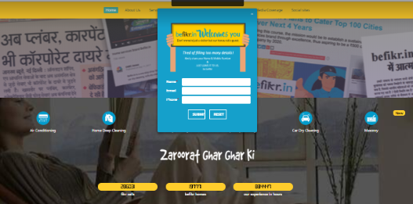

Fig 2.1 Front page of former website

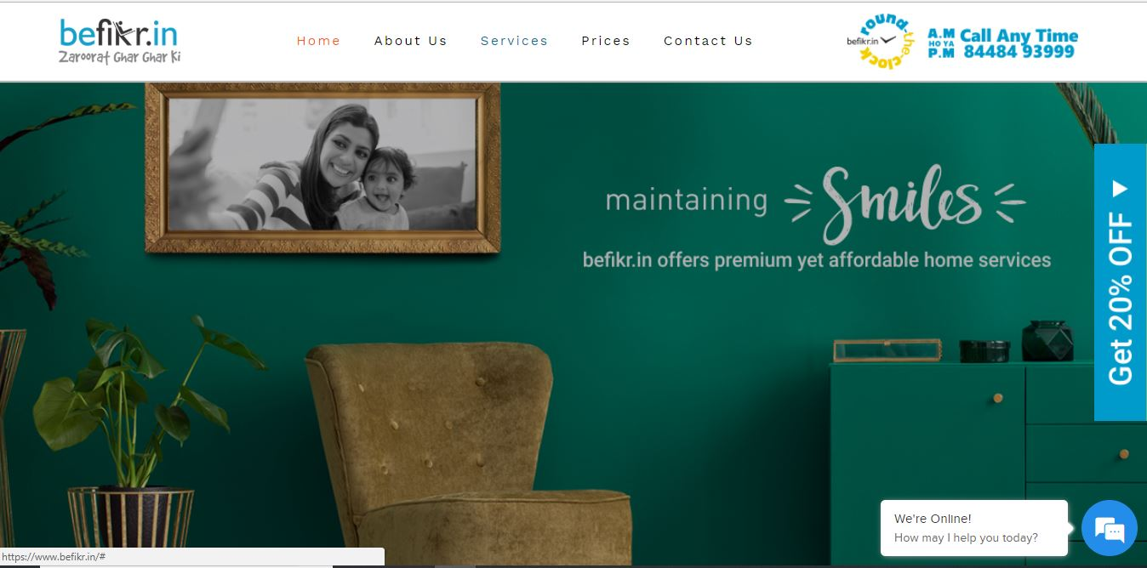

Fig no 2.2 Front page of the new website designed

**Services Provided:**

The most important task of any site is the services provide by it.If a user will find the difficulty in finding the service or can not find the service required then the site is of no use. So the biggest task was to organize the services properly so that the user can find the service easily.For that several changes were made in the service selection procedure, the services were sort into main five columns ‘maintenance’ ,‘installation’ , ‘repairs & services’, ‘cleaning’ , ‘renovation’. This made is more organized. The changes were as follow:

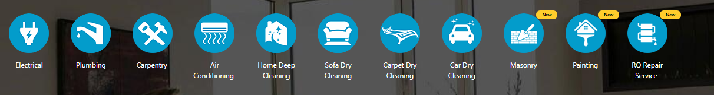

Fig 2.3 layout of service provided in former site

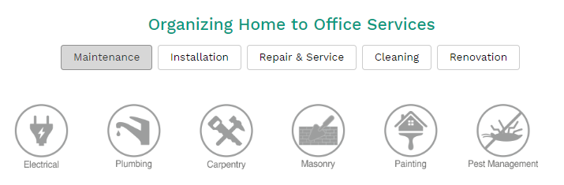

Fig 2.4 Layout of service provided in new site

Price List:

In comparison of the other features of the site, price selection for the required service was the biggest problemfaced by the company, as user find it slightly difficult to find the price for their services. As the first thing about the site seen by the user is the price, as India is a money-conscious country, cost matters to us.For that the services were divided in the category "maintenance", "installation","repair& services", "cleaning", "renovation",and then they were divided in to the subcategory as for AC services the prices are shown in fig 2.7.

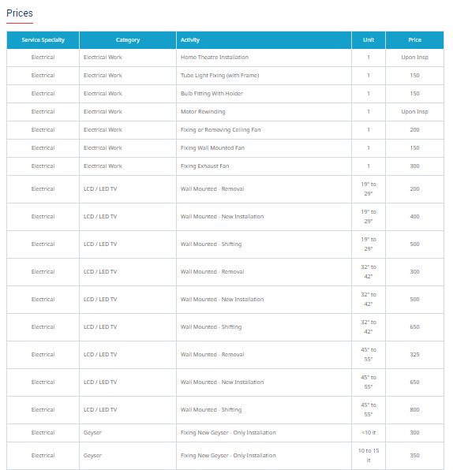

Fig 2.5 Price List of services in former site

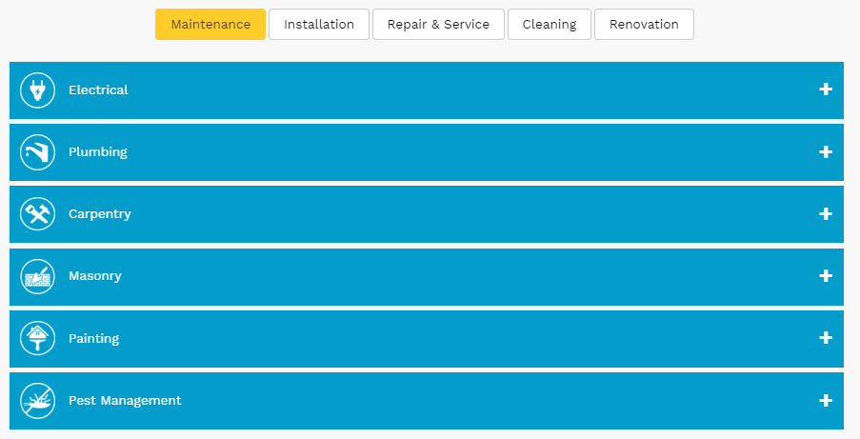

Fig 2.6 Price List of services in new site

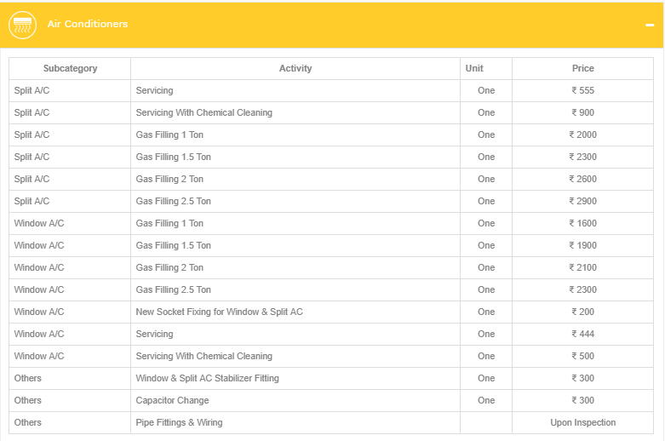

Fig 2.7 Categorized Price list in new site

The Work Flow:

The next step was to improve the work flow of the site. The essentials features required by a customer were brought together on the flow of home page. All the basic details in site to attract and satisfy the customer were there, whether that be ‘About us’ or the link to android and ios app, from our news partners to the cities we provide in, all were present in-home page. 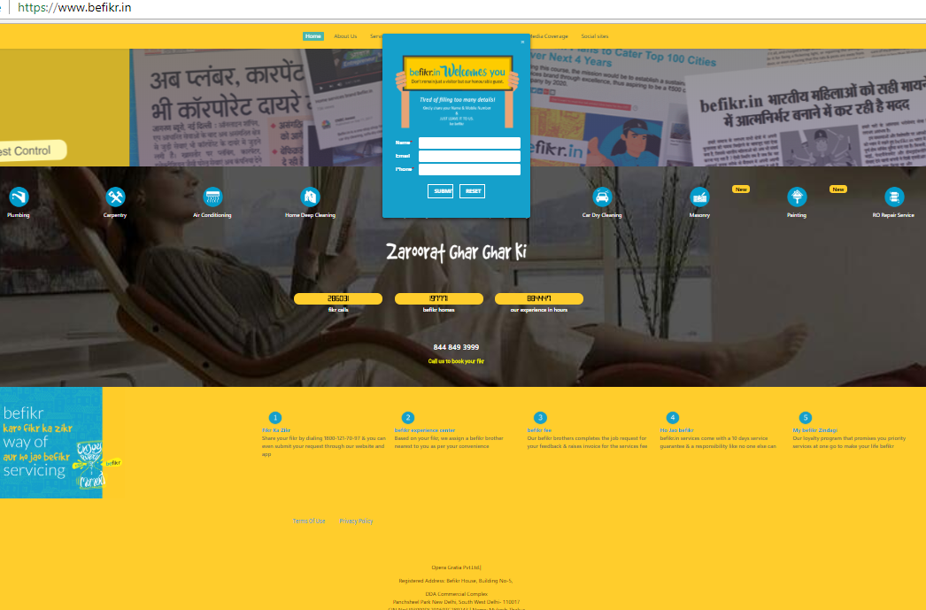

Fig2.8 Work Layout of former site

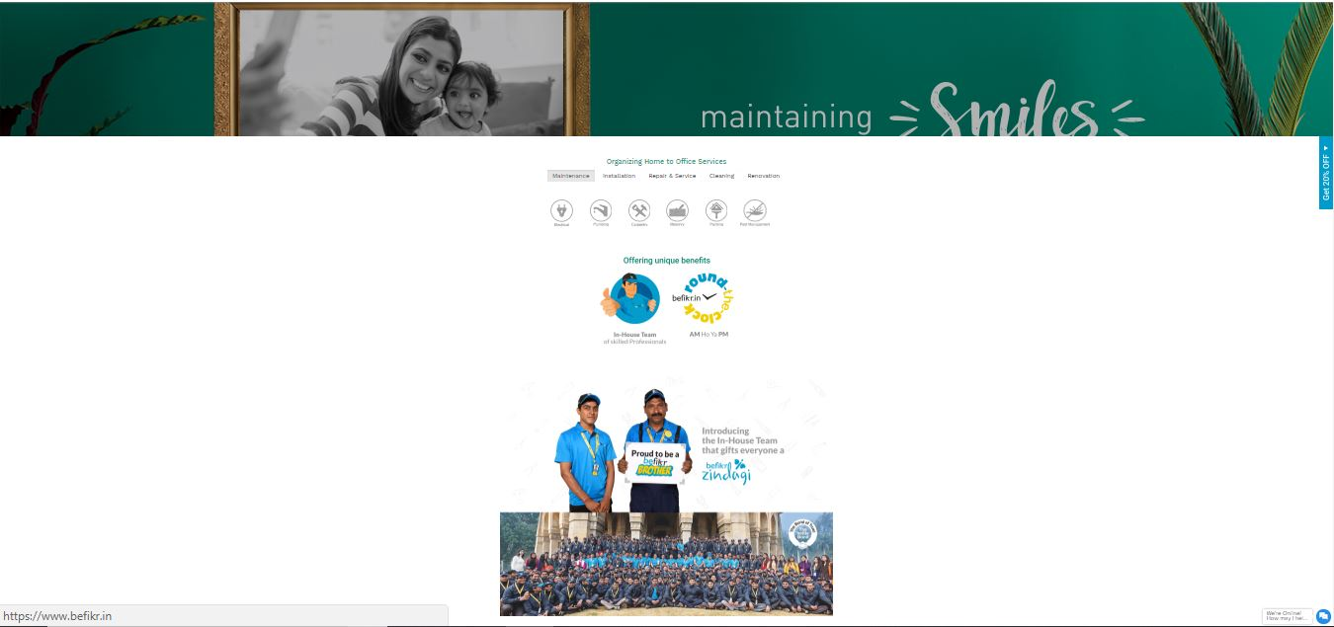

Fig2.9 Work Layout of new site

Few more Essential Changes:

Beside from the major changes there were few more essential changes made in the new site which hold equal value for the enhancement of the site. The changes were as follows

1. Chat Box:

Some changes were introduced in the chat section. It is now more convenient for the user to know their query. Now-a-days the user doesn’t give their information easily and try to avoid that, keeping that in mind this chatting section is designed.

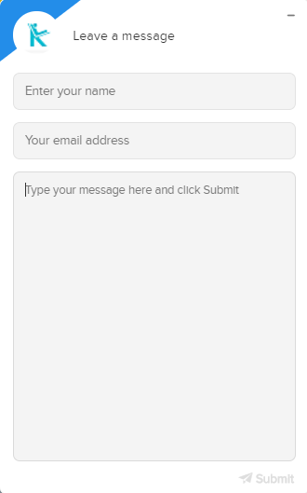

Fig 2.10 Chat Section

1. Link to the App store:

One new feature is added to the website, the app’s link. The app is user friendly and it is a good convenience for all the existing user as now they can easily book the required service.

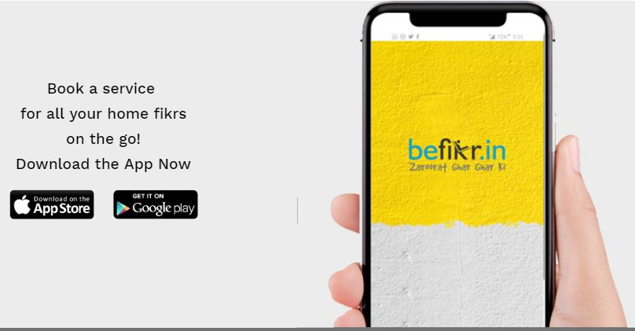

Fig 2.11 Play-store app logo in the website

1. Discount Voucher:

Discount voucher is added on the first page to attract more and more customer towards the services.



Fig: 2.12 Discount coupons on the website

1. Login Page:

In the previous website, you need to login all your details before booking the required service, but if you see now a days no one easily wants to share his/her information easily as in fig.2.13. After this login page a basic page opens that ask for your address, which complicates the procedure. So, a change was made in the login layout of the website the details are still required but in the minimal form.

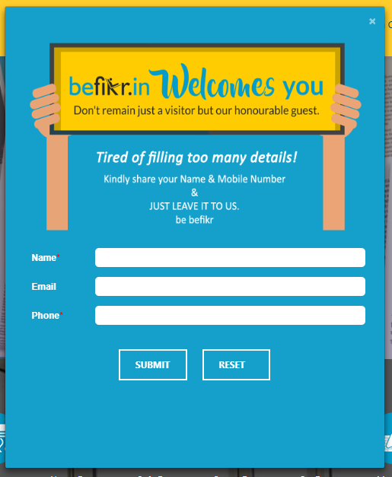

Fig: 2.13 Login page of the former page

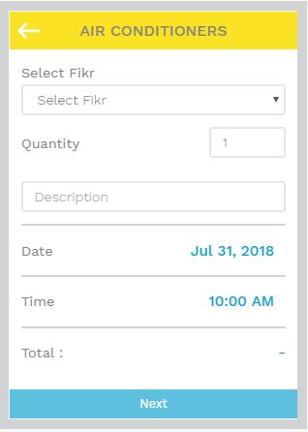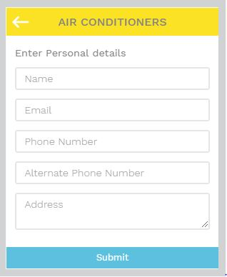

Fig:2.14 Login page of new website

Marketing Strategy

Goals are designed to inspire action and focus attention on specific desired outcomes. After setting the goals marketing strategy or marketing plan was to be developed to get the attention of the customers. The marketing strategy plan provides an outline of the specific actions to be taken over time to achieve the objectives. Our strategy was gain followers for our Organisation through a reputed legitimate company. Befikr.in collaborated with BSES and Atomberg to work together in order to gain business and attention. BSES Rajdhani Power Limited, A joint venture of Reliance infrastructure Ltd. & Govt. of NCT of Delhi is amongst the most admired and most trusted integrated utility companies in the India. On the other hand, there is Atomberg, with a strong core team of IIT-IIM alumni, providing with India’s most energy efficient appliances which simply cannot be competed on the parameters like design, look, price, and the energy saver technology.

Keeping in line with our vision and values we put up stalls at BSES offices at different locations in Delhi to sell the India’s most energy efficient fan, Gorilla by Atomberg to which Befikr.in was the authorized service provider. The aim was to deliver reliable and quality products and services to all customers at competitive costs, with standards of customer care- thereby creating superior value for all stakeholders.

The collaboration resulted in favorable terms for all the three Organisations, as soon as the people started understanding the technology and the money saving formula we started earning the trust and confidence of all the customer by exceeding their expectations, we achieved high growth in sales. Each fan sold got a new customer for Befikr.in now and forever. Our ultimate goal is to work with vigour, dedication and innovation keeping total customer satisfaction.

**CHAPTER 3**

**CONCLUSION**

It was an absolute worthwhile experience working at befikr.in. The friendly welcoming staff and the space they have created for trainees/ interns allowed me with ample opportunity to learn and know myself as a professional. As the organization is a startup where there is lot of strategies and polices to be framed for its smooth functioning, I as an intern got an opportunity to learn many things. I learned what challenges does the organizations faces at its initial level of growth and how do they tackle them, all these added more confidence to my professional approach to build up a strong positive attitude and taught me how to work in a team as a player. The primary objective of an internship is to gather a real-life working experience and put theoretical knowledge in practice. And I am grateful that somewhere I was able to apply my understandings during my internship. Working with the IT Department made me realize my competencies and level of understandings regarding the software development.

Though I was an intern but the staff always treated me as the part of the organization and there were no limitations, I managed to grab lot of experience. I realized that there is some gap between the theoretical knowledge and real life practice.

Hence, I can sum up by saying that my internship experience was a milestone to my academic and professional experiences. I thoroughly learned a lot from my industrial exposure by facing small challenges each day. These lessons that I have learned will be a valuable for my future endeavors as well.

**CHAPTER 4**

**FUTURE SCOPE**

The organization is still working on the website and trying to up bring all the possible and innovative ideas possible in the site, as it is the website that directly presented to the customer. The website is the first thing they see about the organization, it is basically the overlook or the outer layer of the organization.

There are some changes that are going to be updated in the V1 version of the website.

1. One pop-up page will be introduced through which the user can select the city in which they want the required service. This will make it easier for the consumer and for the organization to locate the service. One more sub-feature will be added to this that the consumer will see the services according to the city selected.
2. There will be a search option in the header to make it easier for the consumer to find the required service in less time.
3. There will be few changes in the chat section, the chat will be directly controlled through the automated chat system, where half of the answer will be directed by the system so that the befikr experience center divert most of the time in the customer problem solving section.
4. A new befikr buzzer is going to be added on this website, so that if you press the buzzer immediately you’ll get a response from the befikr experience center, if you are using that buzzer for the first time you will get Rs 50 in your befikr wallet.
5. Blogs section is going to be added on the website to increase the visiting of the site. This section will help the organization in many ways as the more people visiting to the site the high are the chances for them to book a service, it also increase the overall rating of the site to make it best home services providing website.

**References**

1. <https://www.befikr.in/>
2. <https://www.urbanclap.com/>
3. <https://www.w3schools.com/js/default.asp>
4. <https://www.tutorialspoint.com/javascript_online_training/javascript_while_loop.asp>
5. <https://www.helpr.in/>
6. <https://www.w3schools.com/css/default.asp>
7. <https://stackoverflow.com/>
8. <https://www.javatpoint.com/css-tutorial/>